LONGITUDINAL ANALYSIS OF BODY WEIGHTS OF COWS

Section 1: Review of DLZ Analysis

  - Data Review
The study presented in Diggle, Liang ad Zeger (DLZ) involves the body weights of cows over time. The data is provided by Dr Andrew Lepper from the CSIRO Division of Animal Health in Melbourne. The study population consisted of a random sample of 27 cows. The participating cows’ bodyweights were measured at 23 unequally spaced time intervals over a period of about 22 months. These unequally spaced time intervals spread from 122 days to 781 days. The time scale is transformed such that t_{ij} runs from j = 0,…,66. This transformation is given by:

t_{ij} = (time in days – 122) , where each unit represents 10 days.
10

The response variable was also transformed into log-bodyweights in order to stabilise the variance over time. The graphical analysis showed that a particular cow exhibited an abnormally low weight gain pattern throughout the experiment and was accordingly removed (subject 6). A closer investigation of the data also revealed that the 11th observation (time = 445) for subject 4 was also an outlier and was omitted from the analysis. Its value was 5.521.

The remaining sample of 26 cows (n = 26) were then allocated amongst treatment groups in a 2 x 2 factorial design. The two factors are:

- presence / absence of iron dosing
- presence / absence of infection by the organism M. paratuberculosis

Table 1: Replications in the four groups: control, iron, infection and both.
Treatment Group | Infected | Not Infected
Iron | 10 | 3
No Iron | 9 | 4

Table 1 summarises the distribution of the four groups in the experiment. There are 4 cows in the Control group, 3 in the Iron group, 9 in the Infection group and 10 in the Both group.
  - Identification of key scientific hypotheses

The study examines the relationship between bodyweight and the factorial effects over time. In particular, whether the presence of iron dosing and/or M. paratuberculosis affects the weight patterns observed over time. An important hypothesis is whether the mean response exhibits the typical growth pattern by showing “an initially sharp increase before gradually levelling off as it approaches an asymptote” for each group. It is postulated that low-degree polynomials, particularly linear models, provide poor approximations to this behaviour. To test the accuracy of this hypothesis,

t_{ij} was centred such that t_{cj} = t_{ij} – 33, where t_{cj} denotes centred time,

the following model was fitted to the data on the log-bodyweights of cows:

Y_{ij} = _{j} + _{ij} if i  control
j= 1,…,n_{i}
_{j} + _{0g} + _{1g} t_{cj} + _{2g} t_{cj}² + _{ij} if i  group g,
g  {iron, infect, both}

This model specifies that each treatment contrast is a quadratic function of time, while the control mean is described by a separate parameter at each of the 23 time points. Fitting such a second-order polynomial model raises several important issues, namely:

- Can the model be simplified into a linear framework? In other words, are the quadratic effects needed?
H₀: ₂₁ = ₂₂ = ₂₃ = 0

- Is the main effect of the treatment group ‘Iron’ significant?
H₀: ₀₁ = ₁₁ = ₂₁ = 0

- Is the main effect of the treatment group ‘Infection’ significant?
H₀: ₀₂ = ₁₂ = ₂₂ = 0

- Is the interaction effect significant?
H₀: ₀₃ = ₀₁ + ₀₂ ; ₁₃ = ₁₁ + ₁₂ ; ₂₃ = ₂₁ + ₂₂
  - Summary of analysis presented by DLZ

Covariance Structure
After fitting a saturated model for the mean response, with a separate parameter for each combination of time and treatment, the ordinary least squares residuals were extracted to construct an empirical variogram. DLZ found that a model consisting of random effects, serial correlation and measurement error reasonably described the covariance structure. That is,

Var() = ²J + ²H + ²I
H_{ij} = exp(-d_{ij}²/²)

After making the necessary reparameterizations, the theoretical variogram takes the following form:

(u) = ²{₁ + 1 – exp(-₃u²)}

The variogram showed that the measurement error variance ² is relatively small while the between-animal variance (random effects) ² is very large. The shape of the variogram near the origin also suggested that a Gaussian correlation function was a more appropriate choice than an exponential.
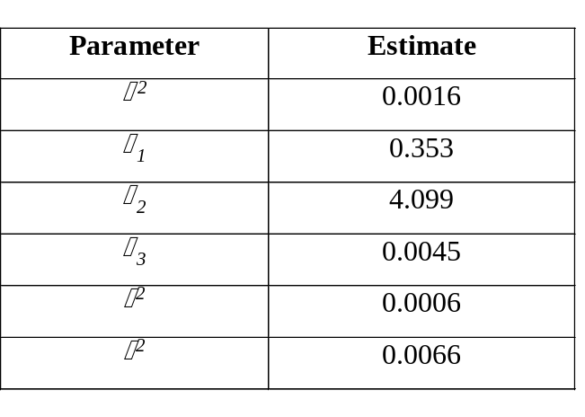Table 2: Estimated parameters in the covariance structure

These estimates confirm that the dominant component of the variation is between animals, with ₂ ₌ 4.099 and ² > ² > ².

Tests of Significance
The analysis suggests that the decision to include quadratic effects as a function of time was a valid one. The chi-squared test statistic to test the hypothesis,

H₀: ₂₁ = ₂₂ = ₂₃ = 0

is reported as T₀ = 10.785 on 3 degrees of freedom, which corresponds to a p-value of 0.02. This significant result means that a quadratic description of the factorial effects is reasonable and the null hypothesis is rejected.

The tests of significance for the two main effects and the interaction between them are summarised in the following table:

Table 3: Summary of tests of main effects for each treatment level.
 | Null Hypothesis | T₀ | p-value | Accept / Reject H₀
Iron | H₀: ₀₁=₁₁=₂₁=0 | 1.936 | 0.586 | Accept
Infection | H₀: ₀₂=₁₂=₂₂=0 | 14.32 | 0.003 | Reject
Interaction | H₀: ₀₃=₀₁+₀₂ ; ₁₃=₁₁+₁₂ ; ₂₃=₂₁+₂₂ | 0.521 | 0.914 | Accept

Table 3 indicates that there is a highly significant main effect of infection. On the other hand, the main effect of iron and the interaction effect are both insignificant. Consequently, DLZ concludes that the final model be reduced to fit only an infection effect. The resulting estimate for the contrast between the mean response with and without infection is:

(t_{c}) = -0.167 – 0.00134 t_{c} + 0.0000566 t_{c}²
(0.042) (0.00044) (0.00002)

The estimated standard errors for the intercept, linear and quadratic coefficients are the italicised values underneath the equation. To compare the estimates under the provisional model with the equation above, refer to the Table A in the Appendix.

  - Critique and recommendations
In order to present a critical appraisal of the DLZ analysis, there are numerous issues that need to be considered. Firstly, it is important to confirm the reported statistics and test results by performing the same analysis. Surprisingly, our own investigations led to different conclusions regarding several fundamental hypotheses. In particular, DLZ reported that the model required quadratic component, supported by the significant chi-square test statistic T₀ = 10.785 and a corresponding p-value of 0.02. However, our analysis using SAS reveals conflicting results. In fact, when examining the equivalent statistic T₀ = 1.84 which corresponds to a p-value of 0.1390.
Table 4: Summary SAS output ‘Type 3 Tests of Fixed Effects’ using REML estimation method for the Gaussian
Effect | Numerator DF | Denominator DF | F-value | Pr > F
timej | 20 | 543 | 28.88 | < 0.0001
groupl | 3 | 543 | 7.55 | < 0.0001
ctime(groupl) | 3 | 543 | 3.84 | 0.0097
ctime2(groupl) | 3 | 543 | 1.84 | 0.1390

This highly insignificant result indicates that quadratic effects are jointly not needed at all! Thus, it would be sensible to simplify the model into a general linear framework and remove the squared centred time component, denoted by t_{c}² or ctime2(groupl). A possible explanation for the substantial discrepancy between the reported findings by DLZ and our analysis is the standard errors used to calculate the test statistics. Since standard errors of the quadratic effects might be sensitive to the fit of the autocorrelation structure, the use of robust regression to obtain more reasonable estimates of standard errors may support the conclusion drawn by DLZ. Moreover, the specification of an exponential function (rather than the Gaussian) for the serial correlation component of the covariance structure might also be worthwhile investigation. Nonetheless, the validity of the quadratic structure certainly warrants further scrutiny due to this apparent inconsistency.

There are also other discrepancies in the parameter estimates for the fixed effects, treatment contrasts and covariance structures. These are summarised in Tables B, C and D in the Appendix. Table B suggests that the parameter estimates for fixed effects did not differ dramatically from our results, while the test statistics for the main effects for each treatment level, found in Table C were also not too dissimilar. On the hand, the divergence in the covariance parameter estimates between the DLZ findings and our analysis is more pronounced.
Section 2: Analysis of the data with time transformed to a square root scale

2.1 Exploratory data analysis
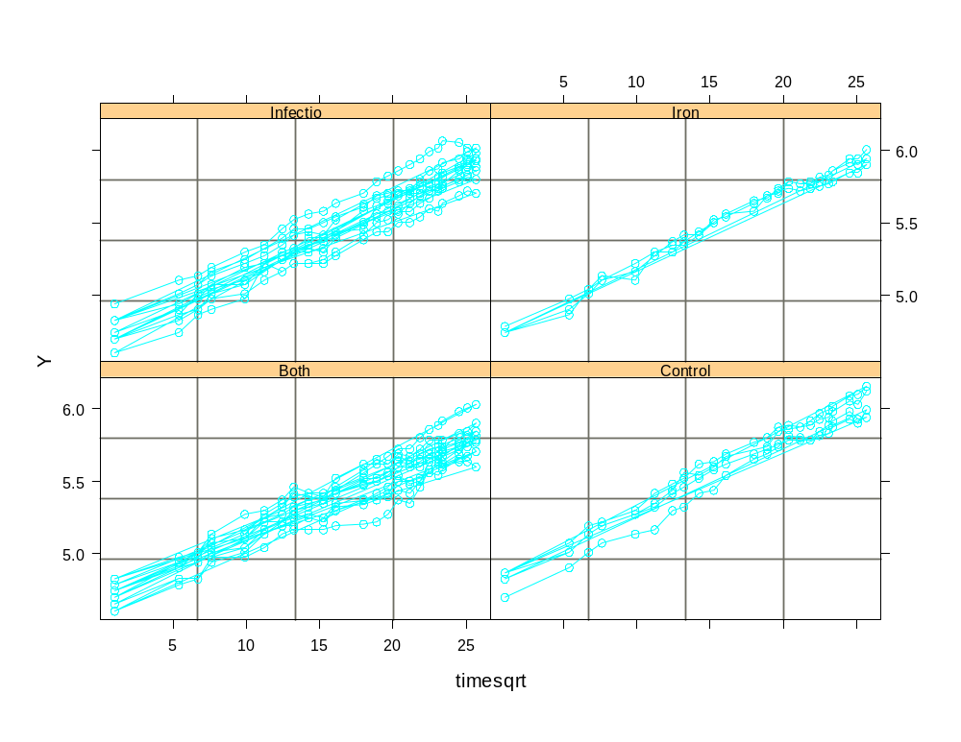
The first step is to replace the time scale t_{ij} with (t_{ij} – 121)^{0.5}. The outliers outlined Section 1.1 have also been removed from the analysis. The resulting data is shown in Figure 1, where Y denotes log-bodyweight and timesqrt denotes the transformed time scale.
Figure1: Log bodyweights of cows in a 2 X 2 factorial experiment.

As a result of the time-scale transformation, the curves for each treatment group no longer display quadratic features as in DLZ. In fact, the mean response profiles appear to be approximately linear, just by visual impression. For a clearer picture, refer to Figure A in the Appendix.
Covariance structure
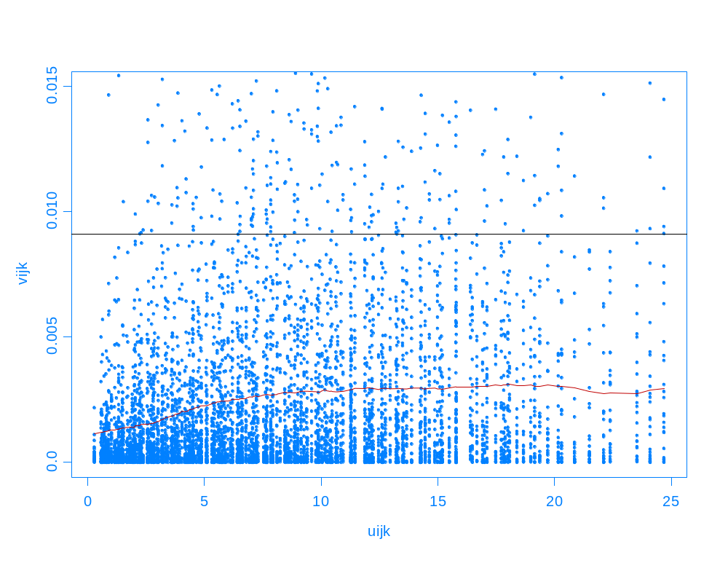
The next step involves fitting a saturated model for the mean response, with a separate parameter for each combination of timesqrt and treatment. The summary output of the linear model can be found in the Appendix under ‘S-plus Output 1’. The sample variogram is then constructed by using the residuals from the linear fit cowwt.lm
Figure 2: Sample variogram of the residuals. The individual points represent the basic quantities (uijk,vijk), the red line is the kernel smooth estimate of (u) and the horizontal line is the residual variance.

The sample variogram appears to be reasonably similar to the one obtained by DLZ. To accentuate the shape of the variogram, particularly near the origin, refer to Figure B in the Appendix for a graph without the individual points. A prominent feature in this diagram is the behaviour of the variogram at the lower lags, particularly between u = 0 and u = 5. Like in DLZ, the shape of the variogram near the origin implies that Gaussian type decay in serial correlations may be present. As for the other components of the covariance structure, the measurement noise is quite small while the random effect is very large. This again is consistent with DLZ findings.

The analysis above leads us to formulate an appropriate model for fixed and random effects. Since the mean response is approximately a linear function of the transformed time scale, our model should not include any quadratic effects. Moreover, because our main interest focuses on the factorial effects, we follow the DLZ approach of modelling only contrasts between treatments, rather than treatment means themselves. As such, _{j} drops out of the analysis and we are left with a model in the form:

Y_{ij} = _{0g} + _{1g} t_{cj} + _{ij} g = 1,2,3,4
i  group g
j= 1,…,n_{i}

Further, the Gaussian correlation function is the preferred over the exponential given the features of the empirical variogram in Figure 2. However, we shall also consider the exponential correlation function in the following sections to provide comparative analysis for the model fits.

  - Model fitting using SAS PROC MIXED
Given the model identified in Section 2.1, Restricted Maximum Likelihood (REML) and Maximum Likelihood (ML) methods were applied using SAS to produce the required parameter estimates. The code can be found in the Appendix under ‘SAS code 1’. The following table provides the estimated coefficients for fixed effects using the REML estimation method:

Table 5: Summary SAS output ‘Solution for Fixed Effects’ using REML estimation method for the Gaussian
Treatments | Parameter | Estimate | Std. Error | DF | t-value | Pr > |t|
Iron (1) | ₀₁ | 5.3257 | 0.0472 | 567 | 112.95 | < 0.0001
 | ₁₁ | 0.0489 | 0.0016 | 567 | 30.83 | < 0.0001
Infection (2) | ₀₂ | 5.2844 | 0.0272 | 567 | 194.12 | < 0.0001
 | ₁₂ | 0.0466 | 0.0009 | 567 | 50.91 | < 0.0001
Both (3) | ₀₃ | 5.2241 | 0.0258 | 567 | 202.29 | < 0.0001
 | ₁₃ | 0.0436 | 0.0009 | 567 | 50.16 | < 0.0001
Control (4) | ₀₄ | 5.4005 | 0.0408 | 567 | 132.26 | < 0.0001
 | ₁₄ | 0.0504 | 0.0014 | 567 | 36.67 | < 0.0001

Covariance Parameters
Table 6 displays the covariance parameter estimates using REML while Table 7 provides the reparametrized estimates similar to values obtained in Section 1.3.

Table 6: Summary of SAS output ‘Covariance Parameter Estimates’ using REML method for the Gaussian
Parameter | Estimate | Std. Error | Z-value | Pr > Z
Intercept (²) | 0.0061 | 0.0020 | 3.01 | 0.0013
Variance (²) | 0.0021 | 0.0004 | 5.54 | < 0.0001
SP (GAU) () | 4.7149 | 0.6214 | 7.59 | < 0.0001
Residual (²) | 0.0007 | 0.0001 | 13.09 | < 0.0001
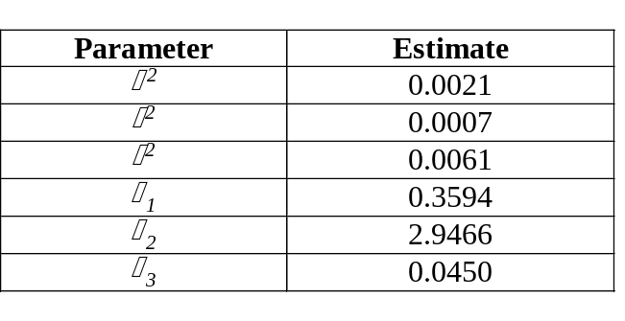
Table 7: Estimated parameters in the covariance structure

Given these covariance estimates, a variogram for the fitted model is constructed using:

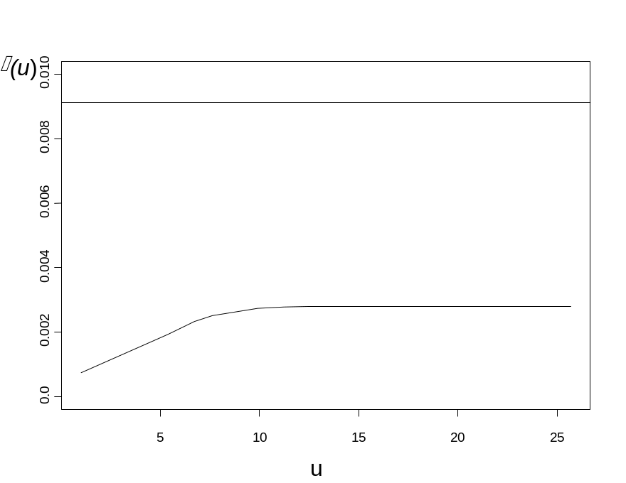(u) = ²{₁ + 1 – exp(-₃u²)}
Figure 3: Fitted variogram using covariance parameter estimates

  - Analysis
- Tests of Fixed Effects
Table 8: SAS output ‘Type 3 Tests of Fixed Effects’ using REML and ML methods for both correlation structures
 | Effect | Numerator DF | Denominator DF | F-value | Pr > F

REML:
Gaussian | groupl | 4 | 567 | 27214.10 | < 0.0001
 | ctime(group1) | 4 | 567 | 1850.74 | < 0.0001
Exponential | groupl | 4 | 567 | 27222.00 | < 0.0001
 | ctime(group1) | 4 | 567 | 1595.40 | < 0.0001

ML:
Gaussian | groupl | 4 | 567 | 32106.40 | < 0.0001
 | ctime(group1) | 4 | 567 | 1986.76 | < 0.0001
Exponential | groupl | 4 | 567 | 32077.40 | < 0.0001
 | ctime(group1) | 4 | 567 | 1764.64 | < 0.0001

The highly significant results obtained under all the models suggest that the mean response is correctly specified and that fitting a model within a general linear framework is appropriate.

Tests of Main Effects for each treatment level
Table 9: SAS output ‘Contrasts’ using REML and ML methods for both correlation structures
 | Label | Num. DF | Den. DF | Chi-square | F-value | Pr > Chisq | Pr > F
REML:
Gaussian | Iron | 2 | 567 | 1.99 | 1.00 | 0.3690 | 0.3690
 | Infection | 2 | 567 | 11.17 | 5.58 | 0.0038 | 0.0040
 | Both | 2 | 567 | 31.99 | 15.99 | < 0.0001 | < 0.0001
 | Interaction | 2 | 567 | 0.45 | 0.22 | 0.7993 | 0.7993
Exponential | Iron | 2 | 567 | 2.03 | 1.01 | 0.3629 | 0.3635
 | Infection | 2 | 567 | 10.37 | 5.19 | 0.0056 | 0.0059
 | Both | 2 | 567 | 29.05 | 14.52 | < 0.0001 | < 0.0001
 | Interaction | 2 | 567 | 0.31 | 0.16 | 0.8549 | 0.8549
ML:
Gaussian | Iron | 2 | 567 | 2.29 | 1.15 | 0.3182 | 0.3189
 | Infection | 2 | 567 | 12.63 | 6.31 | 0.0018 | 0.0019
 | Both | 2 | 567 | 36.09 | 18.05 | < 0.0001 | < 0.0001
 | Interaction | 2 | 567 | 0.52 | 0.26 | 0.7721 | 0.7721
Exponential | Iron | 2 | 567 | 2.34 | 1.17 | 0.3105 | 0.3113
 | Infection | 2 | 567 | 11.99 | 6.00 | 0.0025 | 0.0027
 | Both | 2 | 567 | 33.57 | 16.79 | < 0.0001 | < 0.0001
 | Interaction | 2 | 567 | 0.39 | 0.19 | 0.8246 | 0.8247
Not surprisingly, the results summarised in Table 9 is consistent with the DLZ analysis. That is, there is a highly significant main effect of infection under all model fits. However, the main effect of iron and the interaction effect are both insignificant. This has important implications for the following sections, whereby the final model is to be reduced to fit only an infection effect.
- Tests of covariance parameters

Table 9: SAS output ‘Covariance Parameter Estimates’ using REML & ML methods for both correlation structures
 | Parameter | Estimate | Std. Error | Z-value | Pr > Z
REML:
Gaussian | Intercept (²) | 0.0061 | 0.0020 | 3.01 | 0.0013
 | Variance (²) | 0.0021 | 0.0004 | 5.54 | < 0.0001
 | SP (GAU) () | 4.7149 | 0.6214 | 7.59 | < 0.0001
 | Residual (²) | 0.0007 | 0.0001 | 13.09 | < 0.0001
Exponential | Intercept (²) | 0.0058 | 0.0020 | 2.86 | 0.0021
 | Variance (²) | 0.0028 | 0.0005 | 5.27 | < 0.0001
 | SP (GAU) () | 4.8130 | 1.5365 | 3.13 | 0.0009
 | Residual (²) | 0.0002 | 0.0001 | 2.71 | 0.0034
ML:
Gaussian | Intercept (²) | 0.0051 | 0.0016 | 3.24 | 0.0006
 | Variance (²) | 0.0019 | 0.0003 | 5.66 | < 0.0001
 | SP (GAU) () | 4.5299 | 0.6844 | 6.62 | < 0.0001
 | Residual (²) | 0.0007 | 0.0001 | 12.58 | < 0.0001
Exponential | Intercept (²) | 0.0049 | 0.0016 | 3.11 | 0.0009
 | Variance (²) | 0.0026 | 0.0004 | 6.09 | < 0.0001
 | SP (GAU) () | 4.2786 | 1.2455 | 3.44 | 0.0003
 | Residual (²) | 0.0002 | 0.0001 | 2.49 | 0.0064

Clearly, the four parameter estimates under all the models are highly significant. Thus, all the covariance components are required.

Information criteria

Table 10: SAS output ‘Fit Statistics’ using REML & ML methods for both correlation structures
 | - 2 ln Likelihood | AIC | BIC
REML:
Gaussian | -2114.1 | -2106.1 | -2101.1
Exponential | -2140.4 | -2132.4 | -2127.4

ML:
Gaussian | -2181.1 | -2157.1 | -2142.0
Exponential | -2206.8 | -2182.8 | -2167.7

Under the AIC or BIC criterion for model selection, it is evident that the exponential model for serial correlation outperforms its Gaussian counterpart regardless of what estimation method is used. Thus, our initial assumption of Gaussian correlation structure might be wrong and it is probably a good idea to investigate whether the exponential is indeed the preferred model.

- Graphical analysis
Since the case in favour of the exponential model is becoming more evident, our analysis should be adjusted accordingly. We will now use the parameter estimates attained under the exponential model rather than the Gaussian. Table 11 provides a summary of the SAS output while Figure 4 is a graphical display of the four model fits using the estimated coefficients.

Table 11: Summary SAS output ‘Solution for Fixed Effects’ using REML estimation method for the exponential
Treatments | Parameter | Estimate | Std. Error | DF | t-value | Pr > |t|
Iron (1) | ₀₁ | 5.3224 | 0.0471 | 567 | 112.93 | < 0.0001
 | ₁₁ | 0.0488 | 0.0017 | 567 | 28.57 | < 0.0001
Infection (2) | ₀₂ | 5.2838 | 0.0272 | 567 | 194.17 | < 0.0001
 | ₁₂ | 0.0466 | 0.0010 | 567 | 47.24 | < 0.0001
Both (3) | ₀₃ | 5.2236 | 0.0258 | 567 | 202.34 | < 0.0001
 | ₁₃ | 0.0437 | 0.0009 | 567 | 46.63 | < 0.0001
Control (4) | ₀₄ | 5.3982 | 0.0408 | 567 | 132.25 | < 0.0001
 | ₁₄ | 0.0504 | 0.0015 | 567 | 34.05 | < 0.0001
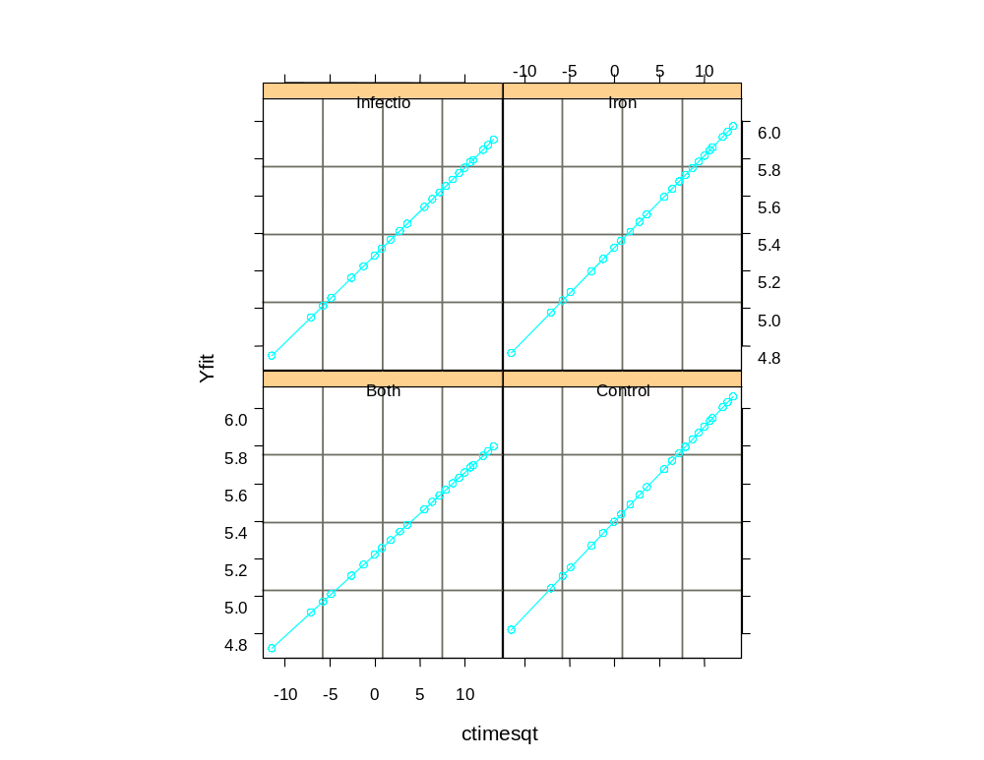 Figure 4: Model fits for each treatment group using the estimated REML
coefficients for the exponential model.
Recall that: Y_{ij} = _{0g} + _{1g} t_{cj} g = 1,2,3,4
i  group g
j= 1,…,n_{i}

Thus, the corresponding Y fits plotted in Figure 4 for each treatment group are in the form:
- Iron
Y_{1j} = 5.3224 + 0.04884 t_{cj}

- Infection
Y_{2j} = 5.2838 + 0.04661 t_{cj}

- Both
Y_{3j} = 5.2236 + 0.04365 t_{cj}

- Control
Y_{4j} = 5.3982 + 0.05041 t_{cj}

- Residuals analysis
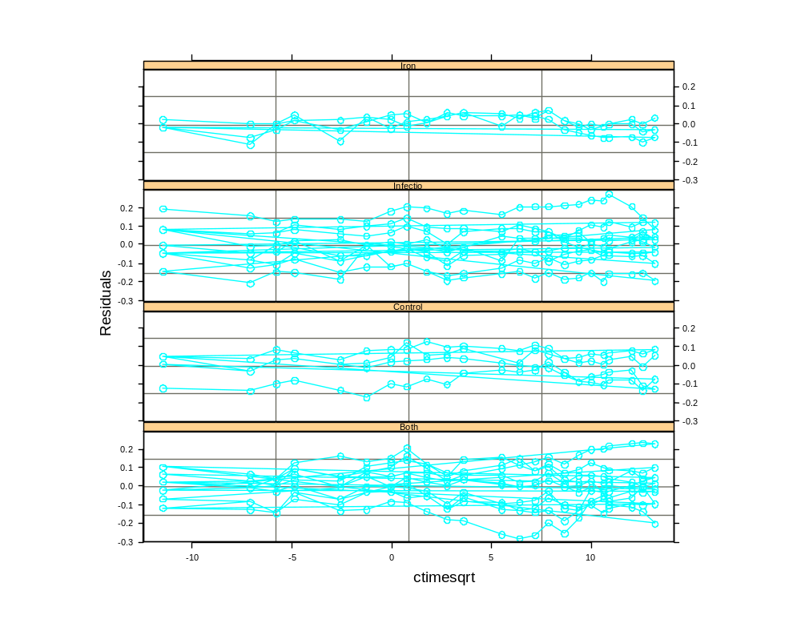Given the Y fits above, the residuals are extracted and plotted against centred square root of time, denoted by ctimesqrt. Figure 5 displays the residuals plots for each treatment group. For a clearer picture, refer to Figure C in the Appendix.

Figure 5: Residuals plots for each treatment group.
Figure 5 suggests that there may have been at least three ‘outlier’ cows that have escaped detection. These cases seem to display unusual behaviour and may indeed be outliers. In particular, the cases that tend not to fluctuate around the zero-axis do display outlier features. These individual cases can be found in the Infection, Control and Both groups. The deviations are either too high or too low to be considered acceptable fits to the data. Nonetheless, Figure C in the Appendix shows that the smooth curves across the transformed time scale for each group appear roughly horizontal about the zero-axis. This implies that the model performed reasonably well, with the Y fits formulated in Section 2.3 (e) enjoying minimum residual variance.

  - Discussion

Based on the analysis outlined in Section 2.3, the recommended final model should first and foremost be simplified. A linear model is the most sensible choice if the time scale is to be transformed in square root dimensions. We found that a second-order polynomial fit to the data is unnecessary given the time transformation. Similarly, the somewhat dubious findings reported by DLZ lend further credence to the argument that a quadratic model is indeed inappropriate.

Secondly, its covariance structure should consist of all three basic elements of variation: random intercepts, exponential decay of serial correlations and measurement noise. Furthermore, the final model should be reduced to fit only an infection effect. That is, the design of the experiment should be modified such that the effects of being infected by M. paratuberculosis is isolated and treated as the sole factor that could affect the bodyweights of cows over time. Because the effects of iron dosing were considered insignificant regardless of the measurement scales of time, having been dismissed by both DLZ and our analysis, keeping it as a factor would be superfluous. Therefore, our new focus should be concentrated on the contrast between the mean response for those cows with infection, and for those that are ‘healthy’. The resulting data set should combine the Infection group with the Both group, while the Control Group with the Iron group. The distribution of this new experiment can be found in Table 12 below:

Table 12: Replications in the two groups: Infection and No Infection
Infection | No Infection
9 + 10 = 19 | 4 + 3 = 7

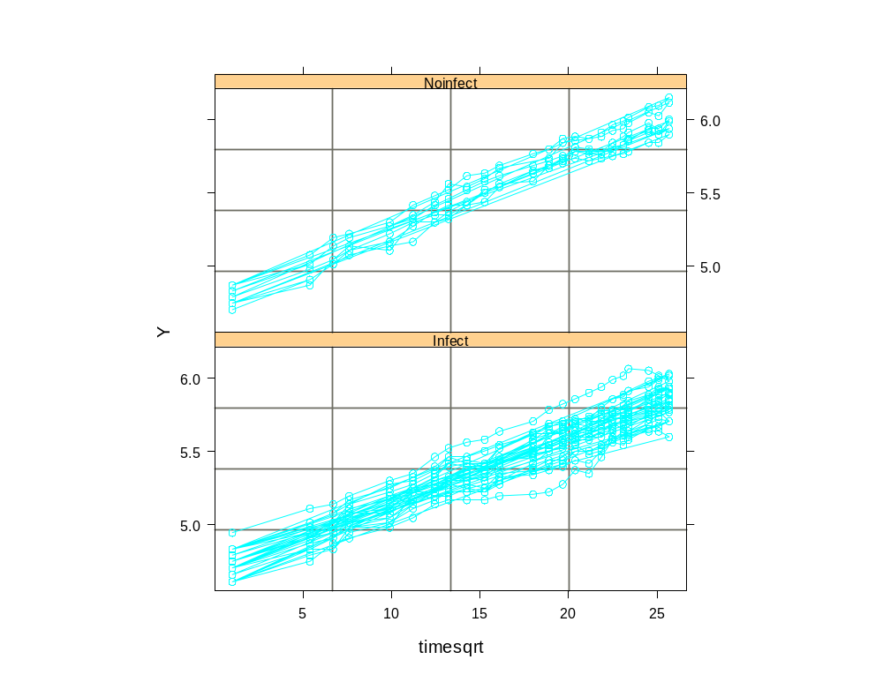
Figures 6 and 7: Log bodyweights of cows in new factorial design.
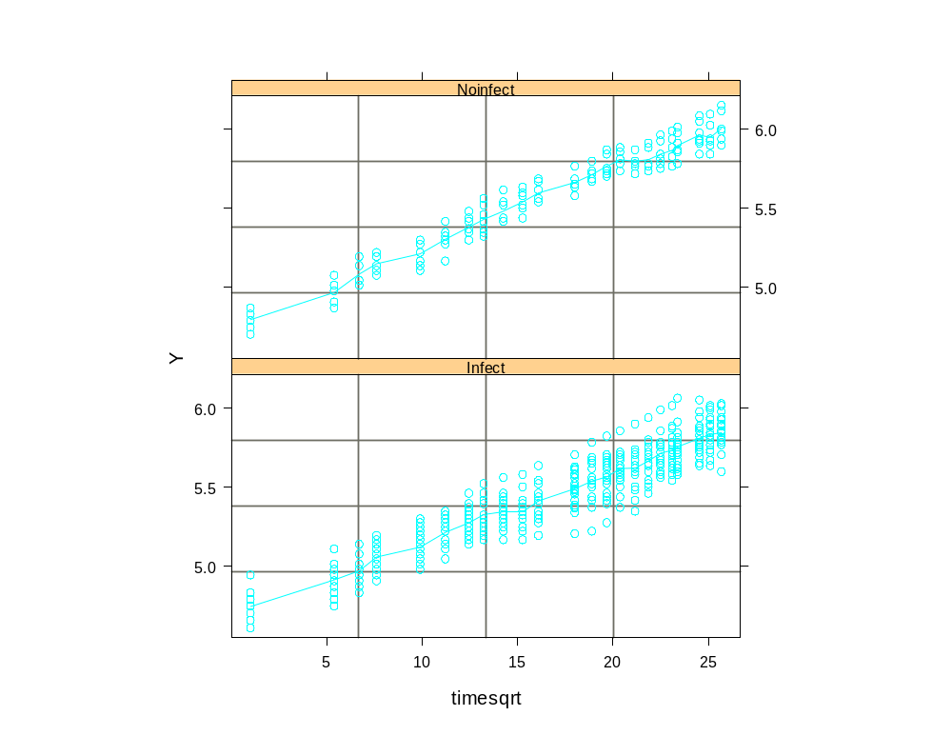
The Final Model
Table 13: Summary SAS output ‘Solution for Fixed Effects’ using REML estimation method for the Final Model
Treatments | Parameter | Estimate | Std. Error | DF | t-value | Pr > |t|
Infect (1) | β₀₁ | 5.2523 | 0.0196 | 569 | 267.64 | < 0.0001
 | β₁₁ | 0.0450 | 0.0007 | 569 | 62.53 | < 0.0001
Noinfect (2) | β₀₂ | 5.3652 | 0.0323 | 569 | 165.95 | < 0.0001
 | β₁₂ | 0.0497 | 0.0012 | 569 | 41.84 | < 0.0001

Table 14: Summary SAS output ‘Covariance Parameter Estimates’ using REML method for the Final Model
Parameter | Estimate | Std. Error | Z-value | Pr > Z
Intercept (υ²) | 0.0063 | 0.0021 | 2.94 | 0.0017
Variance (σ²) | 0.0031 | 0.0006 | 4.93 | < 0.0001
SP (GAU) (ρ) | 5.5800 | 1.7963 | 3.11 | 0.0009
Residual (τ²) | 0.0003 | 0.0001 | 3.05 | 0.0011

Table 15: Summary SAS output ‘Type 3 Tests of Fixed Effects’ using REML method for the Model
Effect | Numerator DF | Denominator DF | F-value | Pr > F
groupl | 2 | 569 | 49585.3 | < 0.0001
ctime(group1) | 2 | 569 | 2830.15 | < 0.0001

Table 16: Summary SAS output ‘Contrasts’ using REML method for the Final Model
Label | Num. DF | Den. DF | Chi-square | F-value | Pr > Chisq | Pr > F
Infect (1) | 2 | 569 | 20.76 | 10.38 | < 0.0001 | < 0.0001

Table 17: Summary SAS output comparing ‘Fit Statistics’ using REML method between different models
Model | - 2 ln Likelihood | AIC | BIC
Final Model | -2161.3 | -2153.3 | -2148.3
Random Coefficients Model | -1875.9 | -1867.9 | -1862.8
Compound Symmetry | -1771.7 | -1767.7 | -1765.2
AR(1) | -2116.2 | -2112.1 | -2109.6

Given the parameter estimates in Table 13, the Final Model has the following form:

(1) Infect
Y_{1j} = 5.2523 + 0.04504 t_{cj}

(2) Noinfect
Y_{2j} = 5.3652 + 0.04966 t_{cj}

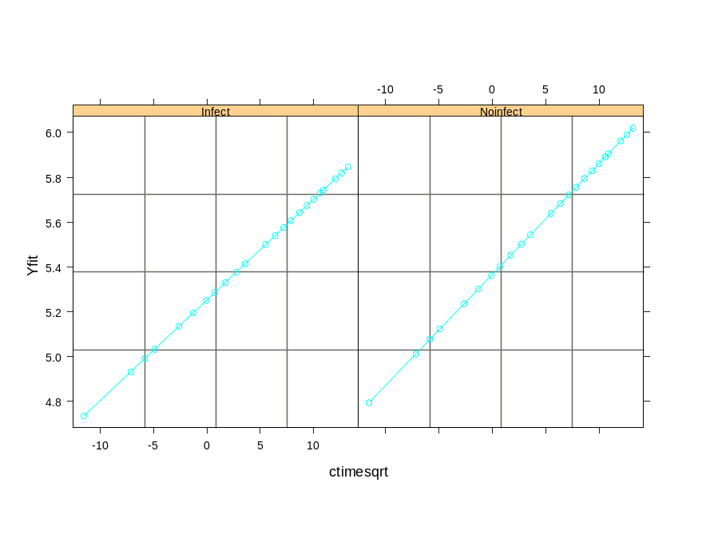
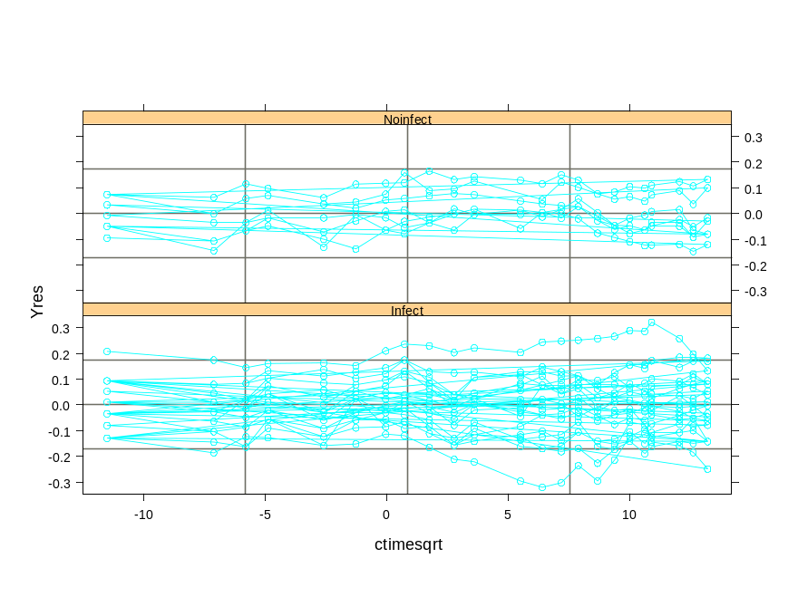
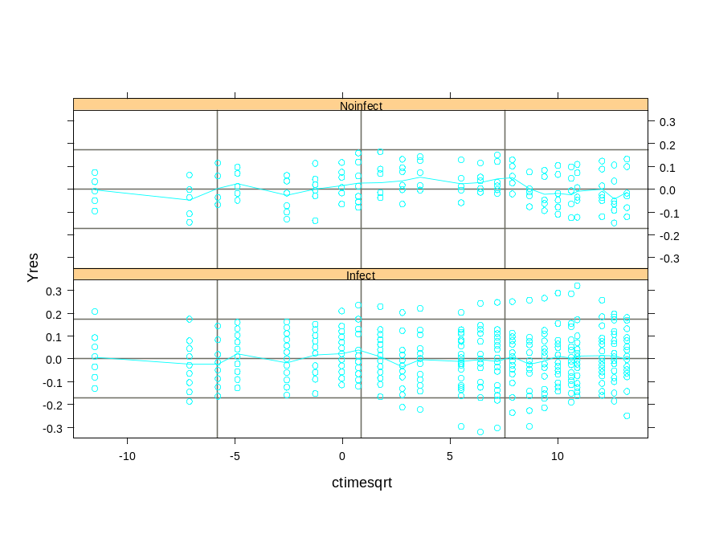
Figures 8, 9 and 10: Figure 8 displays the Final Model fits for the two groups. Figures 9 shows the corresponding residuals plots while Figure 10 displays the smooth curve plots.

- Summary and conclusions
Using the sequence of model building steps undertaken in Section 2, our analysis has led us to the formulation of the Final Model. Given the summary SAS output provided in Tables 13 to 17, it is clear that not only have we come up with a much simpler model to that of DLZ’s, but the Final Model also produced superior fits to the data. The parameter estimates for the fixed effects of the two treatment groups are all highly significant, evidenced in Table 13. The same can also be said about the estimates for the covariance components, provided in table 14. Moreover, Table 15 suggests that a linear formulation of the model is a highly suitable choice for fitting the data under the transformed time scale. Similarly, Table 16 indicates that the main effect of infection is highly significant. Finally, the Final Model outperforms all other competing models under the Information Criteria. Thus, the use of an exponential correlation structure was most beneficial as it provided our analysis a more accurate model for covariance and at the same time, allowed for a superior fit to the data in comparison to other popular alternatives such as compound symmetry and first-order autoregressive models.

In conclusion, the transformation of the time scale played a crucial role in our longitudinal analysis of the bodyweights of cows. The analysis made by DLZ recommend a more complex model for the mean structure under the original measurement scales, claiming that a quadratic description of the factorial effects is more plausible than a simple linear model. However, our analysis demonstrates that a square root transformation of time allows the data to be analysed within a general linear framework. This simplification effectively changes not only the parameters of the mean response profiles, but also potential models for the covariance structure. DLZ advocate the use of the Gaussian decay for the serial correlations. In contrast, under the transformed time scale, our analysis concluded that an exponential correlation function more adequately described the decay properties of the autocorrelations. However, our Final Model is consistent with DLZ’s in one important aspect. Regardless of the time scale, the components of the covariance structure consisted of all three basic elements, namely, random effects, serial correlation and measurement noise. In fact, DLZ estimates for σ², υ² and τ² are very similar to the ones obtained in the Final Model.
Appendix

Table A: Parameter estimates defining the treatment contrasts between the mean response in treatment group g and the control group under the provisional model fitted to the data.
Treatment | Parameter | Estimate | Standard Error | t-value
Iron | ₀₁ | -0.079 | 0.0067 | -11.79
 | ₁₁ | -0.00050 | 0.00071 | - 0.70
 | ₂₂ | -0.000004 | 0.000033 | - 0.12
Infection | ₀₂ | -0.159 | 0.053 | - 3.00
 | ₁₂ | -0.00098 | 0.00056 | - 1.75
 | ₂₃ | 0.0000516 | 0.00026 | 0.20
Both | ₀₃ | -0.239 | 0.052 | - 4.60
 | ₁₃ | -0.0020 | 0.00055 | - 3.64
 | ₂₃ | 0.000062 | 0.000025 | 2.48

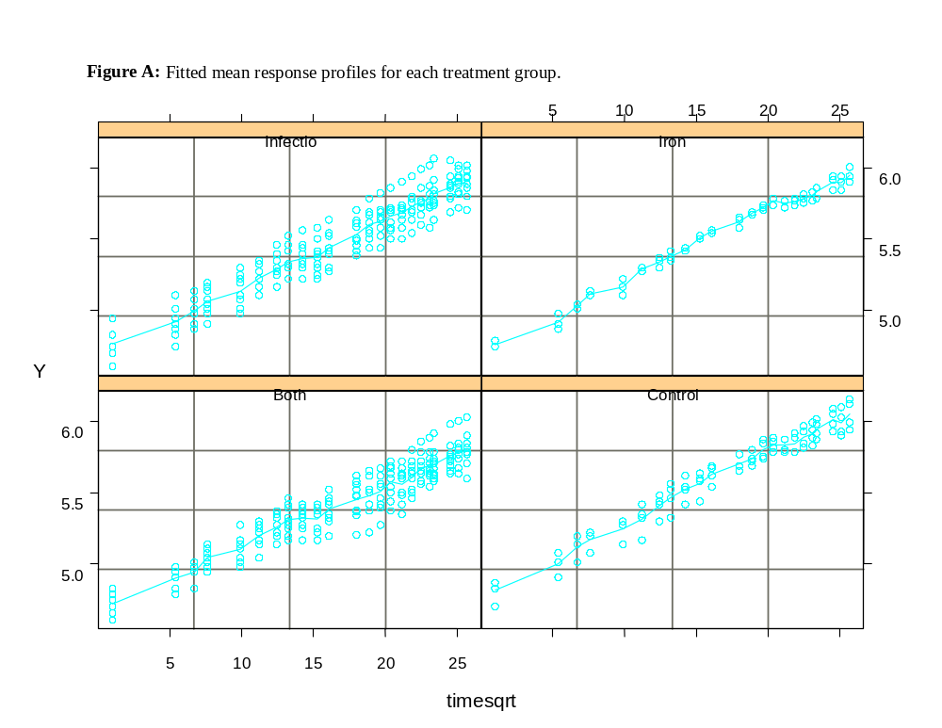
S-plus output 1:
> cowwt.lm_lm(Y~timesqrt*group,data=Cowwt)
> summary(cowwt.lm)

Call: lm(formula = Y ~ timesqrt * group, data = Cowwt)
Residuals:
Min 1Q Median 3Q Max
-0.2815 -0.05845 0.005118 0.05729 0.2649

Coefficients:
Value Std. Error t value Pr(>|t|)
(Intercept) 4.7188 0.0110 429.6517 0.0000
timesqrt 0.0473 0.0006 76.5897 0.0000
group1 0.0455 0.0146 3.1198 0.0019
group2 -0.0151 0.0073 -2.0580 0.0400
group3 0.0018 0.0076 0.2393 0.8109
timesqrtgroup1 0.0035 0.0008 4.2491 0.0000
timesqrtgroup2 0.0003 0.0004 0.7630 0.4458
timesqrtgroup3 0.0004 0.0004 0.9005 0.3682

Residual standard error: 0.09099 on 589 degrees of freedom
Multiple R-Squared: 0.9285
F-statistic: 1093 on 7 and 589 degrees of freedom, the p-value is 0

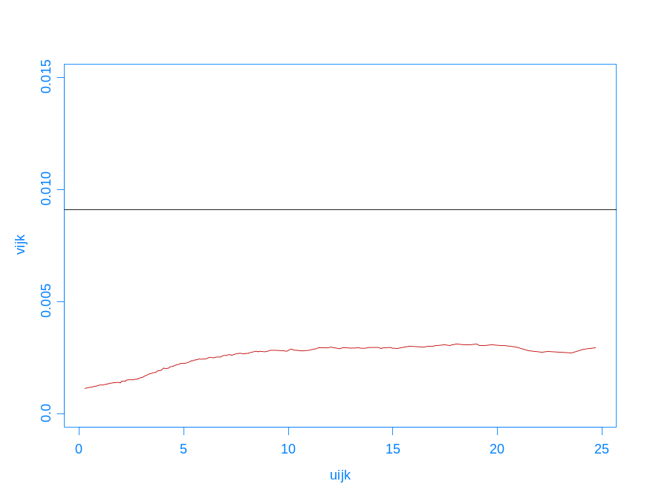
Figure B: Sample variogram without individual points (uijk,vijk)
SAS Code 1:
options ps=56 ls=80;
data cowwt;
input subject $ group $ time Y;
datalines;

[data set]

;
data cowwt2;
set cowwt;
time = sqrt(time–121);
ctime = time–12.5;
if group = “Control” then groupl=4;
if group = “Iron” then groupl=1;
if group = “Infectio” then groupl=2;
if group = “Both” then groupl=3;
obs = _N_;
;
proc mixed data=cowwt2 method=reml covtest;
class groupl subject;
model Y= groupl ctime(groupl) / noint s;
repeated / sub=subject type=sp(gau) (time) local;
random int / sub=subject;
contrast ‘IRON’ groupl 1 0 0 –1 , ctime(groupl)1 0 0 -1 /chisq e;
contrast ‘INFECTION’ groupl 0 1 0 –1 , ctime(groupl) 0 1 0 –1 /chisq e;
contrast ‘BOTH’ groupl 0 0 1 -1 , ctime(groupl) 0 0 1 -1 /chisq e;
contrast ‘INTERACTION’ groupl 1 1 –1 –1 , ctime(groupl) 1 1 –1 –1 /chisq e;
run;

proc mixed data=cowwt2 method=ml covtest;
class groupl subject;
model Y= groupl ctime(groupl) / noint s;
repeated / sub=subject type=sp(gau) (time) local;
random int / sub=subject;
contrast ‘IRON’ groupl 1 0 0 –1 , ctime(groupl)1 0 0 -1 /chisq e;
contrast ‘INFECTION’ groupl 0 1 0 –1 , ctime(groupl) 0 1 0 –1 /chisq e;
contrast ‘BOTH’ groupl 0 0 1 -1 , ctime(groupl) 0 0 1 -1 /chisq e;
contrast ‘INTERACTION’ groupl 1 1 –1 –1 , ctime(groupl) 1 1 –1 –1 /chisq e;
run;

Table E: Summary SAS output ‘Solution for Fixed Effects’ using ML estimation method
Treatments | Parameter | Estimate | Std. Error | DF | t-value | Pr > |t|
Iron (1) | ₀₁ | 5.3257 | 0.0434 | 567 | 122.69 | < 0.0001
 | ₁₁ | 0.0490 | 0.0015 | 567 | 31.96 | < 0.0001
Infection (2) | ₀₂ | 5.2842 | 0.0251 | 567 | 210.85 | < 0.0001
 | ₁₂ | 0.0467 | 0.0009 | 567 | 52.77 | < 0.0001
Both (3) | ₀₃ | 5.2240 | 0.0238 | 567 | 219.72 | < 0.0001
 | ₁₃ | 0.0436 | 0.0008 | 567 | 51.94 | < 0.0001
Control (4) | ₀₄ | 5.4005 | 0.0376 | 567 | 143.66 | < 0.0001
 | ₁₄ | 0.0504 | 0.0013 | 567 | 38.00 | < 0.0001

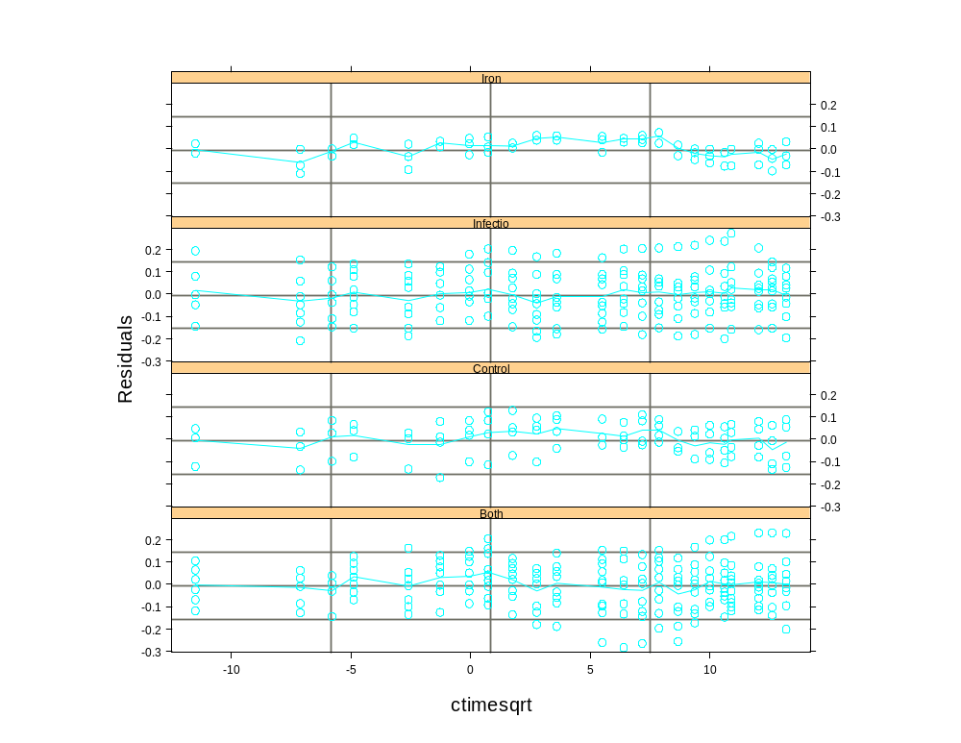
Figure C: Smooth curves for the residuals plots for each treatment group.

Table B: A comparison of estimates for fixed effects
Treatment | Parameter | DLZ estimates | SAS REML
Iron (2) | ₀₁ | -0.079 | -0.080
 | ₁₁ | -0.00050 | -0.00043
 | ₂₁ | -0.0000040 | -0.0000014
Infection (2) | ₀₂ | -0.159 | -0.157
 | ₁₂ | -0.00098 | -0.00106
 | ₂₂ | 0.0000516 | 0.000047
Both (3) | ₀₃ | -0.239 | -0.237
 | ₁₃ | -0.0020 | -0.0021
 | ₂₃ | 0.000062 | 0.000055

Table C: A comparison of test statistics for main effects and interaction effect
Treatment | T₀ (DLZ) | T₀ (SAS REML) | p-value (DLZ) | p-value (SAS REML)
Iron | 1.936 | 1.84 | 0.586 | 0.607
Infection | 14.32 | 11.27 | 0.003 | 0.0109
Interaction | 0.521 | 0.39 | 0.914 | 0.942

Table D: A comparison of covariance parameter estimates
Parameter | DLZ | SAS REML
² | 0.0016 | 0.002588
² | 0.0066 | 0.006099
² | 0.0006 | 0.000534
❑ | 14.9071 | 17.5484
₁ | 0.353 | 0.206
₂ | 4.099 | 2.357
₃ | 0.0045 | 0.00325

Diggle, Liang and Zeger (1994), Analysis of Longitudinal Data, Oxford University Press, pp. 100-106.
Diggle, Liang and Zeger (1994), Analysis of Longitudinal Data, p.102
₁ ₌ ²/²; ₂ = ²/²; Var() = ²(1 +₁ + ₂)
For ease of exposition, we shall only consider the SAS results using the REML estimation method to compare with DLZ findings.
Again, the use of inappropriate estimates of the standard errors could be a possible source of these discrepancies. Robust regression methods or the use of an exponential correlation function may be required for further analysis.
DLZ supports this approach by citing numerous authors who have advocated such methods, including Evans and Roberts (1979), Cullis and McGilchrist (1990) and Verbyla and Cullis (1990).
? To view the ML estimates, refer to Table E in the Appendix. Clearly, the differences between the two estimation methods are minute and should be regarded as negligible. In fact, there does not seem to be any substantial differences between the parameter estimates obtained under the Gaussian and exponential correlation structures.
The complete SAS output for the Final Model, Random Coefficients, Compound Symmetry and AR(1) models are also reported after the Appendix.

